**Functional Pseudo-Protein-Based Biomaterials: Their Fabrication,**

**Biological Property and Biomedical Applications**

Chih-Chang (C. C.) Chu, Rebecca Q. Morgan Endowed Chair Professor

*Biomedical Engineering Program, Department of Biomedical Engineering, & Fiber Science Program, Cornell University, Ithaca, New York, 14853-4402, USA, Email:* cc62@cornell.edu

A new family of functional biodegradable pseudo-protein biomaterials has been designed to advance the design, functionality and biological property of absorbable biomaterials beyond the current commercially popular absorbable polyesters like polyglycolide, polylactide and their copolymers. These new pseudo-protein biomaterials are amino acid-based poly(ester amide)s (AA-PEAs) and their distance relatives, poly(ester urea urethane, or AA-PEUU). AA-PEAs are designed from 3 building blocks (amino acids, diacids and dialcohols), while AA-PEUU are designed from 4 building blocks (amino acids, dialcohols, aliphatic or aromatic diisocyanate, and glycerol a-monoallyl ether). The backbone chemical structures of AA-PEAs and AA-PEUUS have both peptide and non-peptide bonds, and hence exhibit both proteins and non-protein properties, named as “pseudo-proteins”. AA-PEAs and AA-PEUUs can also be coupled with polysaccharides or synthetic polymers to design and fabricate hybrids for achieving even broader range of property and applications [1,2]. These pseudo-protein biomaterials can be engineered into electrospun nanofibrous membranes, melt-spun fibers, micro and nanospheres, 3D microporous hydrogels, micelles, films and 3D printing. Figure 1 shows the images of some these physical forms engineered. The most unique biological property of these pseudo-protein biomaterials are their support of cell adhesion and proliferation, induce muted inflammatory response and blood biocompatible. Pseudo-proteins have been evaluated for some unique biomedical applications ranging from stent and suture coating, vascular patches, biodegradable nanoparticles for drug delivery, 3D tissue printing, 3D microporous hydrogel scaffolds for stem cells tissue engineering, burn wound treatment, non-viral gene vectors to synthetic vaccines.

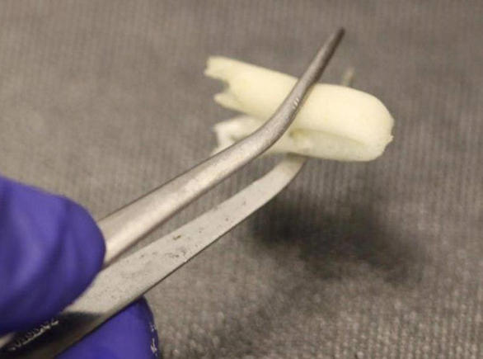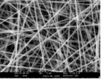

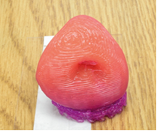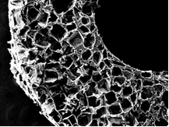**G:\Word\Research\Pub\J Mater Chem\JMC15 - LysPEA Macro to Nano - Wu DQ\Illustrations\origin data for Fig3 and  4 in manuscript submitted to Angew\fig 3\b\NA-Lys-4 biodegradation 7d  under trypsin concentration 0.1 mg-ml .tif**

Figure 1. Variety of physical forms engineered from pseudo-protein biomaterials