C. C. Chu’s Brief BIOS
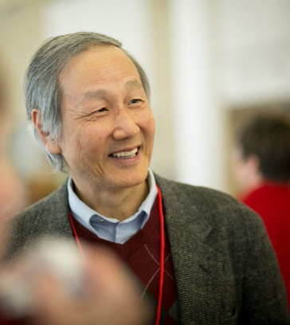
Prof. Chih-Chang (C.C.) Chu received his PhD in chemistry from the Florida State University, Tallahassee, Fla, USA. He is the first recipient of the Rebecca Q. Morgan ’60 endowed chair professor at Cornell University, Ithaca, New York, USA. Chu is the recipient of the State University of New York Chancellor’s Award for Excellence in Scholarship and Creative Activities in May, 2009. Chu was very recently inducted into the College of Fellow of the American Institute of Medical and Biological Engineering in Washington, DC on March 24, 2014. Chu is just elected as the Fellow of the American National Academy of Inventors in Nov. 2018. Chu received the Golden Eagle award from his alma mater, Tamkang University in Taipei, Taiwan in Nov. 2018. Chu is also the distinguished guest professor of Chang-Chun Institute of Applied Chemistry, Chinese Academy of Science in Chang-Chun, Ji-Lin, and the Xi’An Jiao-Tong University, Xi’An, China. Chu also served on the Biology/Medicine Panel of the Hong Kong Research Grant Council from 2010 - 2013, and was a member of the Hong Kong Research Grant Council Collaborative Research Fund Committee. Prof. Chu is in the editorial board of 7 journals like The Open Biomaterial Journal, The Open Material Science Journal, the J. of Bioengineering and Biomedical Sci. and J. Fiber Bioengineering and Informatics. He has published 214 referred research papers (h-index:59; citation: 11,411), a recipient of 79 US and international patents and 30 pending, and an editor and author of the published book “Wound Closure Biomaterials and Devices” by CRC Press, and two-volume books “Biodegradable Polymers: New Developments and Challenging” by Nova Science.
Prof. Chu has focused on the multidisciplinary study of new novel biodegradable polymers/fibers/fibrous membranes invented in his tribe for human body repair. His efforts in the last 15 years have largely focused on the design, synthesis and evaluation of a new novel family of biologic active biodegradable polymers (Pseudo-protein biomaterials) that are would have very unique biological properties like muted inflammatory response, promoting cell growth, facilitating wound healing and would be nontoxic. This new family of biodegradable polymers has also been engineered into a wide range of physical forms/shapes ranging from melt-spun fibers, electrospun fibrous membranes, 3D microporous hydrogels, micelle, micro- and nanospheres; and they have been evaluated for surgical repair of injured or diseased tissues, tissue regeneration like vascular grafts, drug-eluting stents, burn treatment, wound closure and drug control/release purposes. Chu also developed a new course “Biomaterials and Medical Devices for Human Body Repair” for biomedical engineering senior/graduate students.

Chinese version

朱知章是美國長春藤名校紐約州康乃爾大學第一位摩根資深講座教授受獎人. 他的研究和教學均極為出色，除了215餘篇的專業論文,三本專書,及他的研究論文被其他研究人員引用超過1.41萬次，還有超過79個美國和國際專利,和超過200萬美元的專利金。2018年11月，朱知章被選入美國國家發明學院院士，並獲得了母校淡江大學的傑出校友金鷹獎。2014年朱教授被選入美國醫學與生物工程研究院院士, 和紐約州立大學64個校區的學術和創新成就獎。在康乃爾大學, 朱教授研究開發新型解假蛋白質高分子生物材料，用於人體重建和修復。2015年，歐洲醫學管理機構批准朱教授的假蛋白新生物材料的商業用途，作為用於治療冠狀動脈阻塞的新型藥物洗脫支架的表面塗層,更實際嘉惠醫病民生。與香港浸會大學中醫藥研究所合作研究使用朱教授假蛋白納米粒子為中藥提供更加有效乳腺癌治療。朱教授還為生物醫學工程研究生開發了一門新的“人體修復生物材料和醫療器械”課程.

