Speaker bios and photos

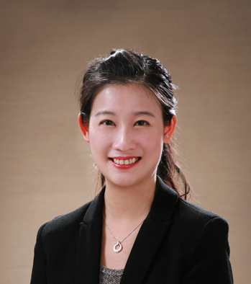
Josephine Cheng 鄭惠中

Josephine is working as the Senior Consultant for Traditional Modalities, Bioprocessing Strategy/ Life Science Division at Merck KGaA, focusing on Vaccine & Plasma market segments in the Asia-Pacific region. She looks closely into market trends, fosters customer collaborations, supports innovation, leads marketing initiatives, and translates insights into sustainable business strategies. Over her 14 years of biopharmaceutical industry experience, she has held various positions ranging from R&D Associate Scientist, Lab Manager, Technology Manager, Training Lead, Segment Marketing Associate Director, and Strategy Senior Consultant. Josephine joined Merck in 2008 and worked in three locations, including Taipei, Shanghai, and Boston. She is a Singapore WDA full-cert trainer (ACLP) and has established regional customer training programs. Josephine holds both Bachelor's and Master's degrees in Bio-resources & Agriculture from the National Taiwan University, focusing on protein expression/purification/monoclonal antibodies preparation. Josephine is also a professional exchange student, where she has completed three academic exchange years at the University of Victoria, Canada / Freie Universität Berlin, Germany/ Snowflake High School, USA. Josephine enjoys ping-pong, jogging, traveling, camping, Korean drama, and language learning in her leisure time.

鄭惠中現任德商默克生命科學部門亞太區核心生醫產業資深顧問一職，主要負責疫苗與血液製品產業拓展之策略建立。鄭惠中在生物醫藥界有十四年的工作經驗，先後任助理研究員，實驗室經理，技術經理，培訓講師, 行業拓展副總監，及策略資深顧問等職位。於2008年加入默克後，先後在台北，上海，波士頓分部工作，也是新加坡勞工發展局頒發的認證培訓講師。畢業於台灣大學生物資源及農學院研究所，主要研究蛋白質異體表現與純化及單株抗體製備技術。在求學過程中參與三次交換生計劃，在美國/加拿大/德國各待一學年。個人嗜好包含桌球，慢跑，旅行，露營，韓劇，語言學習。

